**Phase 1. Collecting and Summarising Urban Data: Glasgow City**

**Policy Problem: Would better access to education improve unemployment rates and the economic model of Glasgow?**

**What is the problem?**

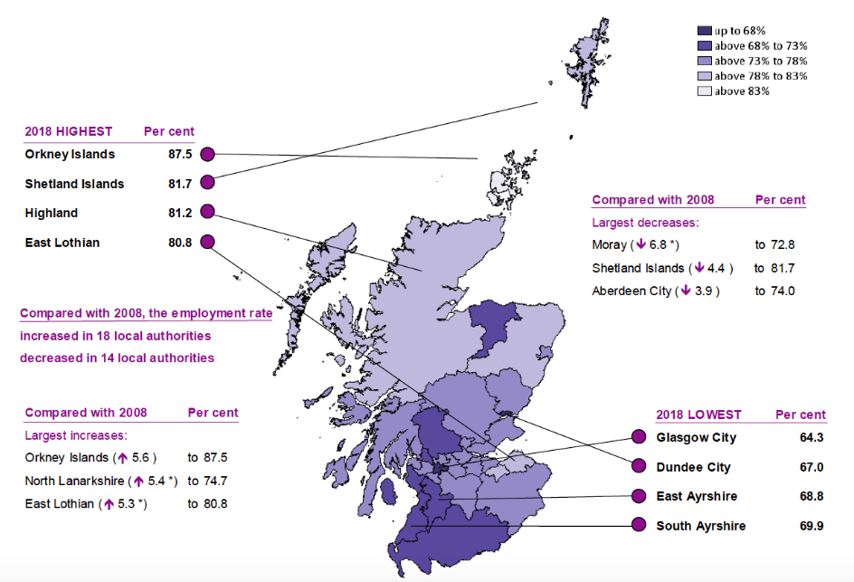Scotland, and Glasgow in particular has a very high rate of unemployment. Data on employment and unemployment rates have shown that Glasgow has one of the highest Model Based Unemployment (MBU) rates in the country. In 2017, the highest MBU rates were seen in North Ayrshire (6.6 per cent), East Ayrshire (5.9 per cent), Inverclyde (5.8 per cent) and **Glasgow City (5.6 per cent)**. The lowest rate was seen in the Orkney Islands (2.1 per cent), to provide comparison.

**Figure 1:** Employment rates in Scotland. Important to notice Glasgow is amongst the highest rates of MBU. (Gov.scot, 2018)

This high rate of MBU varies in areas across Glasgow and has been linked to problems in the city’s education system. As a city, Glasgow is dependent on a stable supply of well-educated workers to promote economic development. The Scottish Government has identified education to be one of the most influential problems on Glasgow’s unemployment rate. They have concluded that (by measuring educational attainment) individuals lacking in secondary school qualifications are on average experiencing unemployment rates much greater than those with a school, college or university qualification.

The Scottish Government stated that:

1. **94.7%** of school leavers from the 20% least deprived areas gained one or more qualifications at SCQF Level 5 or better in 2015/2016. This is compared with **74.4%** of those from the 20% most deprived areas.
2. **81.2%** of school leavers from the 20% least deprived areas gained one or more qualifications at SCQF level 4 or better in 2015/2016. This is compared with **42.7%** of those from the 20% most deprived areas. (Gov.scot, 2018)

The city is currently facing the challenge of providing high quality educational opportunities for its communities, irrespective of their place of residence.

The absence of sound education has led to many of Glasgow’s citizens experiencing forms of disadvantage. This can be most significantly seen in employment. The financial constraints imposed on Glasgow City Council have reduced the local authority’s ability to provide sufficient resources to address this problem of educational disadvantage.

Not only is this having a negative impact on the quality of life and opportunities of individuals, it is also worsening the effects of unemployment, poverty and deprivation in certain areas and communities across Glasgow.

In order to try to meet the economic and social goals of the city, it is necessary to implement an education strategy for Glasgow to close this growing gap and provide a city system of sufficient education and training.

Glasgow City Council needs to strengthen its links between education and employment, as far too many people are passing through the education system without picking up the essential skills needed to succeed. Too many young people leaving school without the sort of knowledge or qualifications which employers demand, job seeking skills and sufficient qualifications go to university or get an apprenticeship.

A policy reform is needed to provide young people with the skills they need to become employable. Putting employment and education side by side could help Glasgow reach its desired future of a reduced unemployment rate, as well as an improvement within the important social and economic levels and organisation of the city. (Duncan, 1961)

In order to try change the nature of Glasgow, there are two key measurable outcomes required for policy reform:

1. Increased employment rates,
2. Improvement in school leavers (16-19) qualification rates, in low employment areas.

In order to reach these outcomes and to address this problem of education and employment, the Executive Director for Education Services at Glasgow City Council (Maureen McKenna) needs to be engaged. As the key decision maker on the problem, she has the capacity to make significant change to the city’s education quality, unemployment rate and overall ‘economic unit.’ (Park and Burgess, 1925, pp.2)

**Data**

To be able to locate the areas of Glasgow in need of educational reform, I have selected data from the Scottish Index of Multiple Deprivation 2020. This data has been extracted from the SIMD 2020 Interactive Map and shows:

|  |  |  |
| --- | --- | --- |
| Data Zone | SIMD 2020 Rank | School Attendance |
| Intermediate Zone | SIMD 2020 Education Domain Rank | School Attainment |
| Council Area | SIMD 2020 Employment Domain Rank | No Qualifications |
| Total Population | Employment Rank | Not Participating |
| Working Age Population | Employment Count | University |

The use of these variables will allow me to find an explanation and some answers for Glasgow’s education and unemployment problem. I will be able to identify the areas that have the lowest school attendance, attainment, qualification and participation levels. With this data I can see if there is a link between the employment rates in these same areas. By identifying specific places, I will be able to locate which zones (and schools within these zones) are to be focused on.

The XLRM framework has been used below to emphasis the match between the data and the policy problem.

(1) Money and funding

(2) Education infrastructure and organisation (schools and employees)

(3) Children and Young People (Scotland) Act 2014

(4) Standard’s in Scotland Schools etc. Act 2000

(5) Young Workforce, Employability and Enterprise Programme

(6) Curriculum for Excellence

(7) Policies for employment

**Policy Levers (L)**

**Relationship in System (R)**

**External**

**Factors (X)**

**Performance**

**Metrics (M)**

Policy reform

Education

Employment

System dynamic relations between the physical, social and economic variables.

Simplified relationship among variables.

(1) Economy (Brexit): economic vulnerability

(2) Council funding (cuts)

(3) School funding

(4) Population increase

(5) Geographical and population distribution in data zones

(6) Poverty rate

(7) Culture

(8) Socio-economic development/changes

(1) Employment rates

(2) School leaver (16-19) qualification rates

(3) University attendance

The data can be opened in R and I was able to successfully run it. However, some issues became apparent. See data dictionary for specific issues (pp.4).

Stevens (1946) levels of measurement were used to describe the information within the data dictionary. Values have been assigned to the different variables (using the nominal and ratio scaling).

Data dictionary only includes data from CSV that is relevant to this policy problem.

**Data Dictionary**

|  |  |  |  |  |
| --- | --- | --- | --- | --- |
| **Variable Name** | **Variable Type** | **Description** | **Summary/Example** | **Issues** |
| Data_Zone | alphanumeric, code | Identifies larger city organisation through key small-areas showing statistical geography of Glasgow. Data zones have populations of between 500-1,000 household residents | S01010257 | Requires only data zones from areas in Glasgow City Council (as this is the study area) |
| Intermediate_Zone | character, string | Aggregations of data zones within local authorities and contain between 2,500 and 6,000 people from 2011   * Smaller unit of city organisation | Strathbungo | Requires the removal of all zones not in the Glasgow City council area |
| Council_Area | character, string | Council area names | Glasgow City | Requires the removal of all council areas except Glasgow City  Additional variable could be added showing which schools are located in each council area |
| Total_Population | numeric, count | 2017 NRS small area population estimates | Max: 2544  Min: 0 | No issue with data |
| Working_Age_Population | numeric, count | Based on 2017 NRS small area population estimate and state pension age | Max: 2361  Min: 0 | No issue with data |
| SIMD2020_Rank | numeric, score | 2020 Scottish Index of Multiple Deprivation rank | Max: 6957  Min: 2 | No issue with data |
| SIMD2020_Employment_Domain_Rank | numeric, score | SIMD data zone education rank from most deprived, to least deprived | Max: 6974  Min: 1 | No issue with data |
| SIMD2020_Education_Domain_Rank | numeric, score | SIMD data zone employment rank from most deprived, to least deprived | Max: 6924  Min: 6 | No issue with data |
| employment_rate | numeric, percentage | Percentage of people who employment deprived | Max: 47%  Min: 0% | No issue with data |
| employment_count | numeric, count | Number of people who are employment deprived | Max: 311  Min: 0 | No issue with data |
| Attendance | numeric, percentage | School pupil attendance | Max: 97%  Min: 43% | Some data has been suppressed because of disclosure control. This has been indicated by ‘* |
| Attainment | numeric, score | Attainment of school leavers | Max: 6.60  Min: 3.36 | Some data has been suppressed because of disclosure control. This has been indicated by ‘*’  Use of n/a |
| no_qualifications | numeric, standardised ratio | Working age people with no qualifications: standardised ratio | Max: 353.08  Min: 11 | Missing fields – for example data zone S01010206 |
| not_participating | numeric, percentage | Proportion of people aged 16-19 not participating in education, employment or training | Max: 33%  Min: 0% | Missing fields for example data zone S01010206 |
| University | numeric, percentage | Proportion of 17-21 year olds entering university | Max: 82%  Min: 0% | No issue with data |

**References**

Duncan, O. (1961). From Social System to Ecosystem. *Sociological Inquiry*, 31(2), pp.140-149.

Gov.scot. (2020). *Regional employment patterns in Scotland: statistics from the Annual Population Survey 2018 - gov.scot*. [online] Available at: https://www.gov.scot/publications/regional-employment-patterns-scotland-statistics-annual-population-survey-2018/pages/7/ [Accessed 28 Feb. 2020].

Park, R. and Burgess, E. (1925). The City: Suggestions for the Investigation of Human Behavior in the City Environment. *American Journal of Sociology*, 20(5), pp.577-612.